Design Guidelines for AS-0.3200 Battery balancer project
Table of Contents
Design Guidelines for AS-0.3200 Battery balancer project 1
Introduction 3
PCB Layout 4
Layer stackup 4
2-Layer PCB 4
4-Layer PCB 4
Traces 4
Vias 4
2-Layer boards 4
4-Layer boards 4
Grids 4
Component placement 4
PCB Trace placement 5
Component selection 6
Passives 6
Diodes – not including leds 6
Discrete transistors – including fets 6
Connectors 6

Introduction
This document outlines the design practices used in this project.The goal is to get a consistent look and feel in project.
The design guidelines also are a sanity check for design choices. It is hard to do horrible mistakes with these guidelines, and any exception should be well thought out and reasoned.
“Autorouter did it” is not a reason for a design choice.

PCB Layout

Layer stackup

2-Layer PCB
Top is signal and bottom is groundplane. Groundplane can be used for jumping, as long as return path of critical signals isn't cut off.

4-Layer PCB
Top: Sensitive and high impedance signals.
1st inner: Ground
2nd inner: Power planes, high current..
Bottom: Non-critical signals.

Traces
Traces are minimum of 0.245 mm / 9 mil thick. This allows for SSOP-packaged IC with rounding errors. Minimum isolation is also 0.245 mm / 9 mil. 0.5 mm / 20 mil traces are preferred.

Vias

2-Layer boards
2-Layer boards are manufactured by hand. This means:
- As few vias as possible. You are going to solder them by hand.
- No vias under components.
2 mm dia pad with 1 mm drill is preferred.
1.2 mm dia pad with 0.6 mm drill is possible.

4-Layer boards
4-Layer boards are manufactured at factory.
No buried or blind vias.

Grids

Component placement
Componets are placed on top side.
Components are placed on a 1.27 mm / 50 mil grid.
Componets are oriented in right angles.

PCB Trace placement
PCB traces are centered to pads.
PCB traces enter pad at right angle.
PCB traces use 45 degree turns.

Component selection

Passives
Passives are 0805 packaged whenever possible.

Diodes – not including leds
Diodes are in SMB / DO-214AA package whenever possible.

Discrete transistors – including fets
Package is SOT323 / SC-70 whenever practical.
Pin order is BCE / GDS.
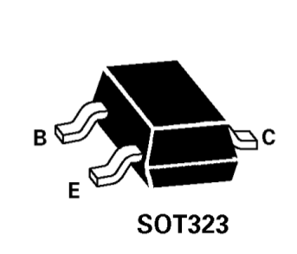

Connectors
For low currents (<1 A) 2.54 mm pitched locking connectors are used.
Example:
http://www.taydaelectronics.com/connectors-sockets/wafer-housing-crimp-terminal/serie-2500-2-54mm/housing-connector-2-54mm-2-pins.html
http://www.taydaelectronics.com/connectors-sockets/wafer-housing-crimp-terminal/serie-2500-2-54mm/wafer-connector-2-54mm-2-pins-right-angle.html
http://www.taydaelectronics.com/connectors-sockets/wafer-housing-crimp-terminal/serie-2500-2-54mm/crimp-terminal-connector-2-54mm.html

For higher currents 5.00 (NOT 5.08) pitched screw terminals are used.
Example:
http://www.taydaelectronics.com/connectors-sockets/terminal-blocks/pcb-mount/dg128-screw-terminal-block-2-positions-5mm.html

